WEEK 7
HADHI VARDHANI K – E25DA048
Importing the Student Performance Dataset
For Week 7, the Student Performance dataset was imported into Power BI for analysis. After importing the dataset, it was opened in Power Query Editor so that the data could be cleaned, transformed and prepared before creating the final report.
The dataset contains information about students along with their scores in three different subjects: Math, Reading and Writing. It also includes details such as gender, race/ethnicity, parental level of education, lunch type and whether the student completed a test preparation course.
The main purpose of this week was to transform the raw student data into a structured format and create useful calculations that can be used to understand the students' overall academic performance
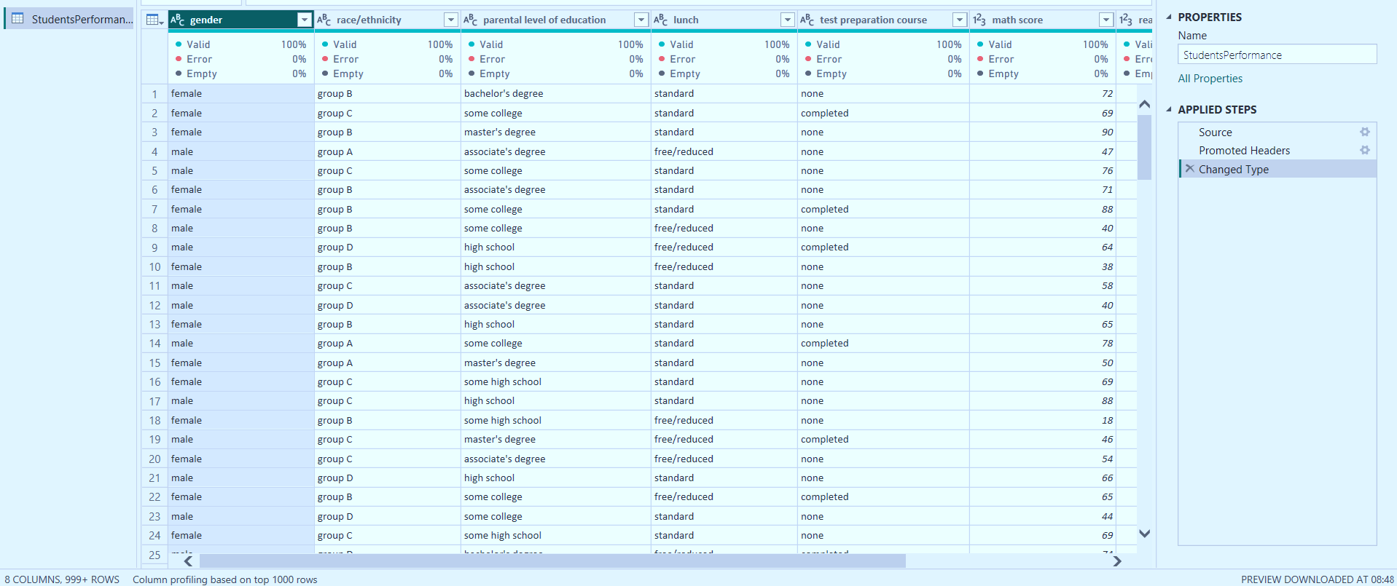

Cleaning Text Data
The text-based columns in the dataset were cleaned using the Clean transformation available in Power Query. This step was performed to remove unwanted or non-printable characters that could affect the quality and consistency of the data.
Cleaning the text values is important because inconsistent or unwanted characters can sometimes cause problems while filtering, grouping or analysing categorical data.
After applying the Clean transformation, the text values were made more suitable for further analysis in Power BI.

Adding Student ID
The original dataset did not contain a unique Student ID for every student. To solve this, an Index Column was added to the dataset in Power Query.
The index starts from 1 and increases by one for every student record. This creates a unique number for each student and makes it easier to identify individual records.
The newly created index column was later renamed to Student ID and was also used while creating the other tables in the data model.
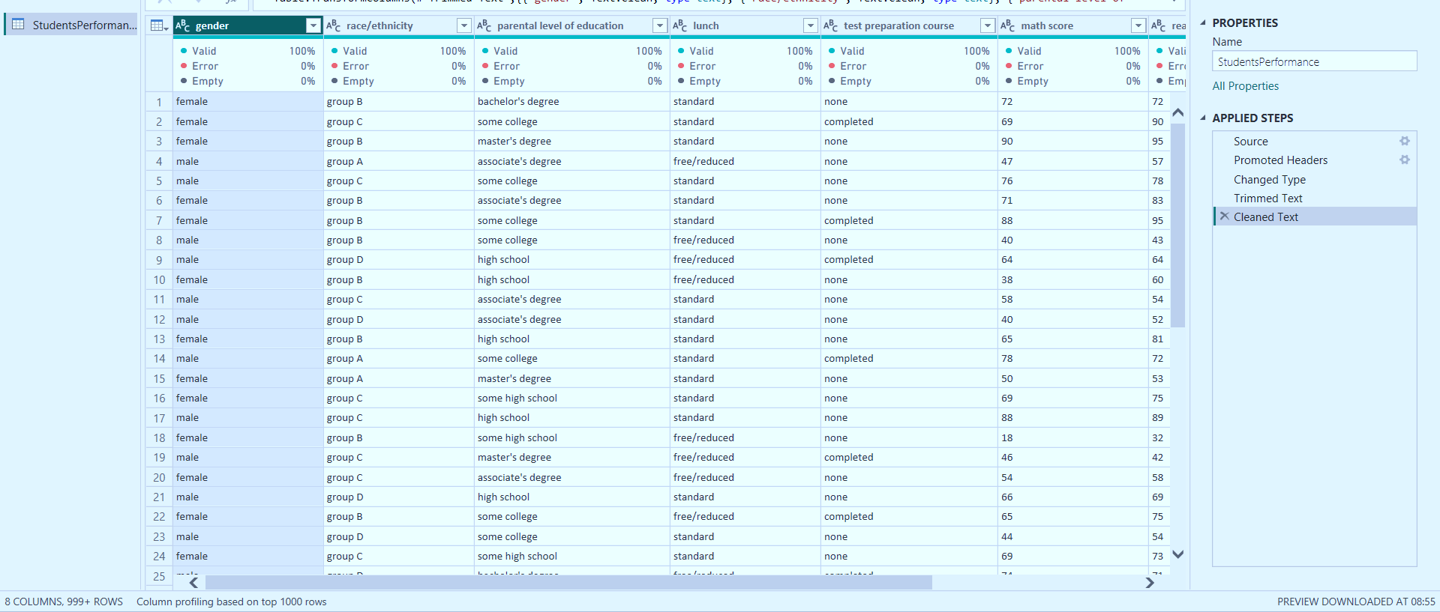
Renaming and Reordering Columns
After creating the index, the column was renamed from Index to Student ID so that its purpose was clear.
The columns were also reordered to place the student identification and personal information first, followed by the subject scores and calculated columns. This made the dataset easier to understand and work with.
Keeping the columns in a logical order also makes the Power Query steps and the final data model more organised.

Creating Total Marks
A new Custom Column named Total Marks was created to calculate the combined marks obtained by each student in all three subjects.
The three subject scores were added together using the following formula:
[math score] + [reading score] + [writing score]
Since each subject has a maximum score of 100, the maximum possible Total Marks is 300.
This calculation gives a quick idea of the student's overall marks across all three subjects.

Total Marks Column
The Total Marks column was successfully added to the dataset. It contains the sum of the Math, Reading and Writing scores for every student.
For example, if a student scored 80 in Math, 75 in Reading and 85 in Writing, the Total Marks would be:
80 + 75 + 85 = 240
This column can be useful when comparing the overall marks obtained by different students.
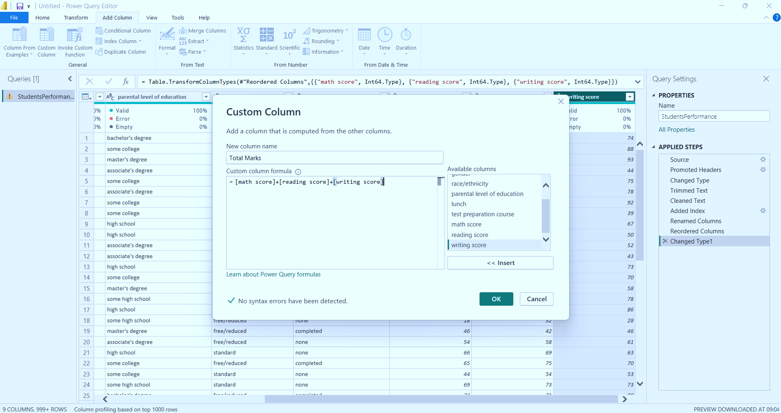
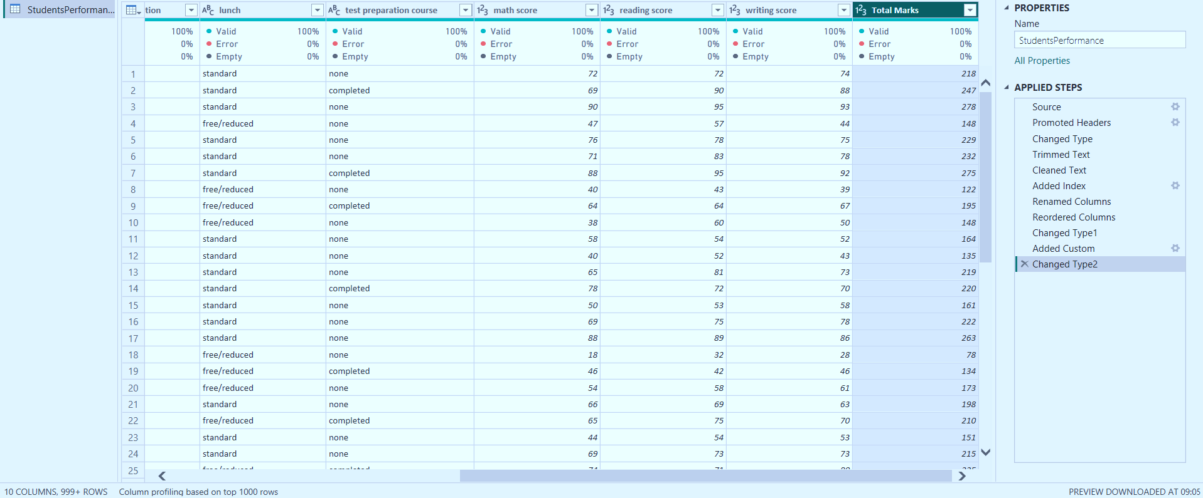
Creating Average Marks
After calculating the total marks, the next step was to calculate the Average Marks of each student.
A new Custom Column named Average Marks was created by dividing the Total Marks by 3 because there are three subjects.
The formula used was:
[Total Marks] / 3
This calculation gives the average score of a student across Math, Reading and Writing.
Using average marks also makes it easier to compare students because the result remains on the same 0–100 scale as the individual subject scores.

Average Marks Column
The Average Marks column was successfully added to the dataset.
The values in this column represent the average academic performance of each student across the three subjects.
For example, if a student has a Total Marks value of 240:
240 / 3 = 80
Therefore, the student's Average Marks would be 80.
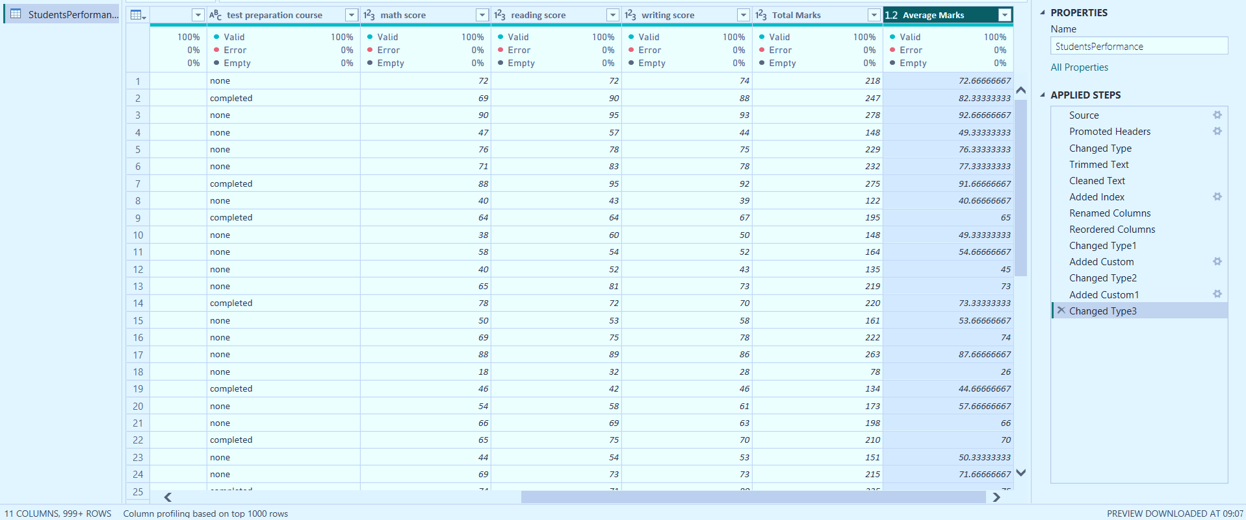
Creating Grade
A Conditional Column named Grade was created using the Average Marks column.
The grading conditions were set according to the student's average score:
- Average Marks ≥ 80 → A
- Average Marks ≥ 60 → B
- Average Marks = 40 → C
- Otherwise → F
The purpose of creating this column was to convert the numerical average scores into simple grade categories.
This makes it easier to understand student performance at a glance. Instead of looking only at numerical values, students can be grouped according to their performance level.

Grade Column
The Grade column was successfully added to the dataset.
Each student is assigned a grade based on their calculated Average Marks. This provides a simple classification of the student's academic performance and can later be used in Power BI visuals for comparison and analysis.

Creating Pass/Fail Result
To identify whether students achieved the minimum required score, another Conditional Column named Result was created.
The condition was based on the Average Marks:
- Average Marks ≥ 40 → Pass
- Otherwise → Fail
This calculation was used to divide the students into two categories: Pass and Fail.
Creating this column makes it easier to calculate the overall pass percentage and analyse how many students successfully met the minimum passing requirement.

Result Column
The Result column was successfully added to the dataset.
Students whose Average Marks are 40 or above are marked as Pass, while students with an Average Marks value below 40 are marked as Fail.
This column was later used while creating the Overall Pass % DAX measure.
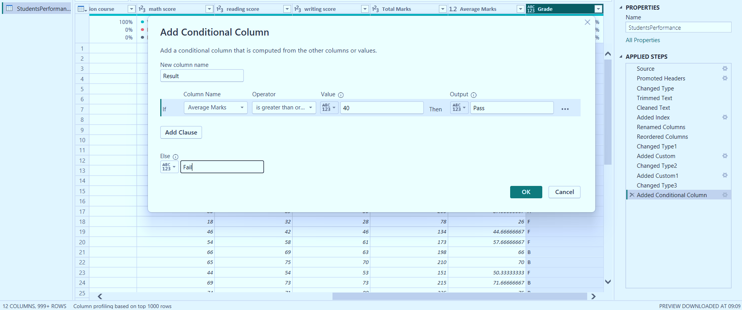
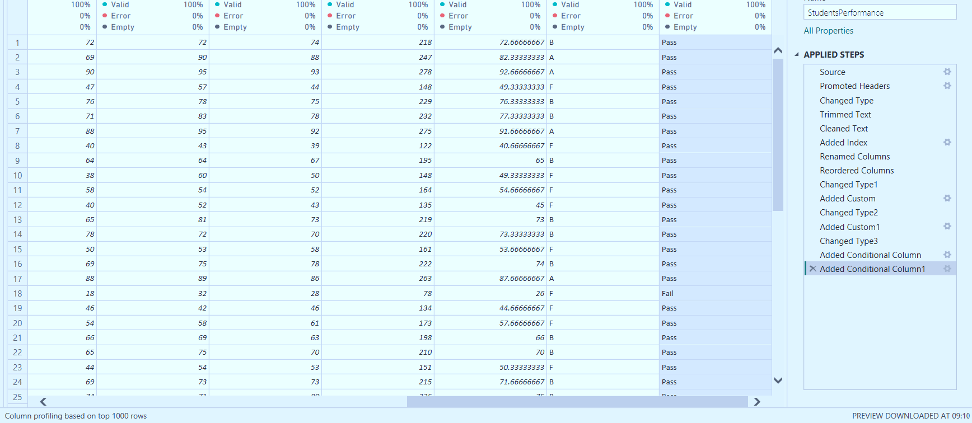
Selecting Student Marks Columns
A separate query named StudentMarks was created from the original dataset.
Only the columns required for subject-wise score analysis were retained:
- Student ID
- Math Score
- Reading Score
- Writing Score
Creating a separate query helps keep the score-related information independent from the other student details.
This also prepares the data for the next transformation, where the three subject columns are converted into a more flexible row-based format.

Unpivoting Score Columns
The three subject score columns were selected in Power Query and the Unpivot Columns option was used.
Initially, the data had separate columns for:
- Math Score
- Reading Score
- Writing Score
After unpivoting, these separate subject columns were converted into rows.
This transformation is useful because it changes the structure of the data into a format that is easier to analyse by subject.
Instead of having three separate score columns, each student can now have multiple rows representing their different subjects.

Renaming Unpivoted Columns
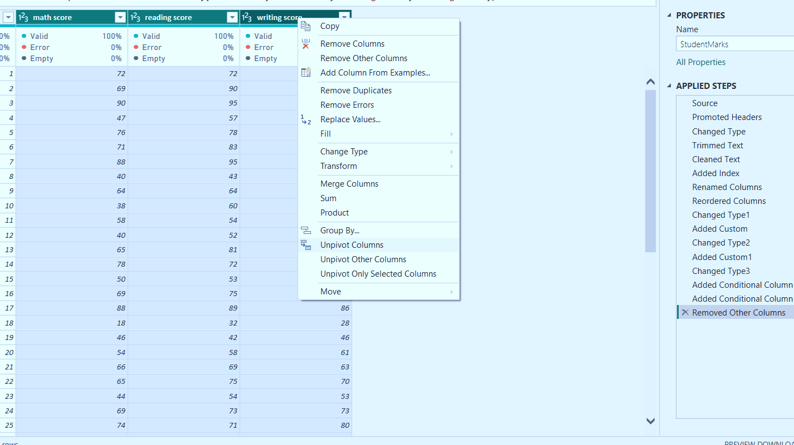
After performing the unpivot operation, Power Query automatically created two columns named Attribute and Value.
To make the table easier to understand, these columns were renamed:
- Attribute → Subject
- Value → Score
The final StudentMarks table therefore contains:
- Student ID
- Subject
- Score
For example, a student's Math, Reading and Writing scores are now represented as separate rows under the Subject column, with their corresponding marks stored in the Score column.
This structure is more flexible and makes it easier to create subject-wise charts and comparisons in Power BI.
Creating StudentDetails
A separate table named StudentDetails was created to store the personal and background information of the students.
The score-related columns and calculated columns were removed from this table because they were not required for storing student details.
The StudentDetails table retains important information such as:
- Student ID
- Gender
- Race/Ethnicity
- Parental Level of Education
- Lunch
- Test Preparation Course
Separating these details from the marks information helps create a cleaner and more organised data model.
It also makes it easier to analyse student performance based on different background characteristics.

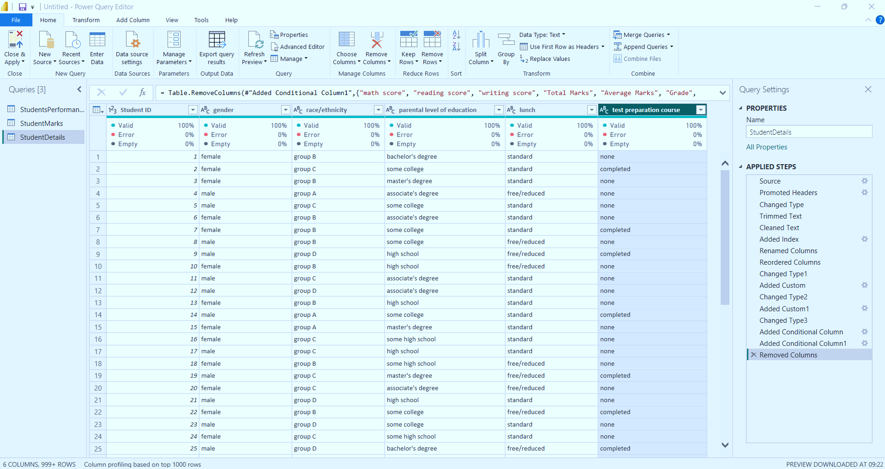
Creating Measures Student Table
A separate table named Measures Student was created specifically to store the DAX measures used in the report.
Creating a dedicated measures table is useful because it keeps all the calculations together rather than mixing them with the actual data columns.
This makes the Power BI model easier to manage and helps identify the measures quickly while creating visuals and dashboards.
The following measures were created in this table:
- Average Math Score
- Average Reading Score
- Average Writing Score
- Overall Average Score
- Overall Pass %

Creating Average Math Score
The Average Math Score measure was created using the DAX AVERAGE function.
The formula used was:
Average Math Score =
AVERAGE(StudentsPerformance[math score])
This measure calculates the average Math score of all students in the dataset.
It can be used in cards, charts and other visuals to provide a quick overview of the students' performance in Mathematics.
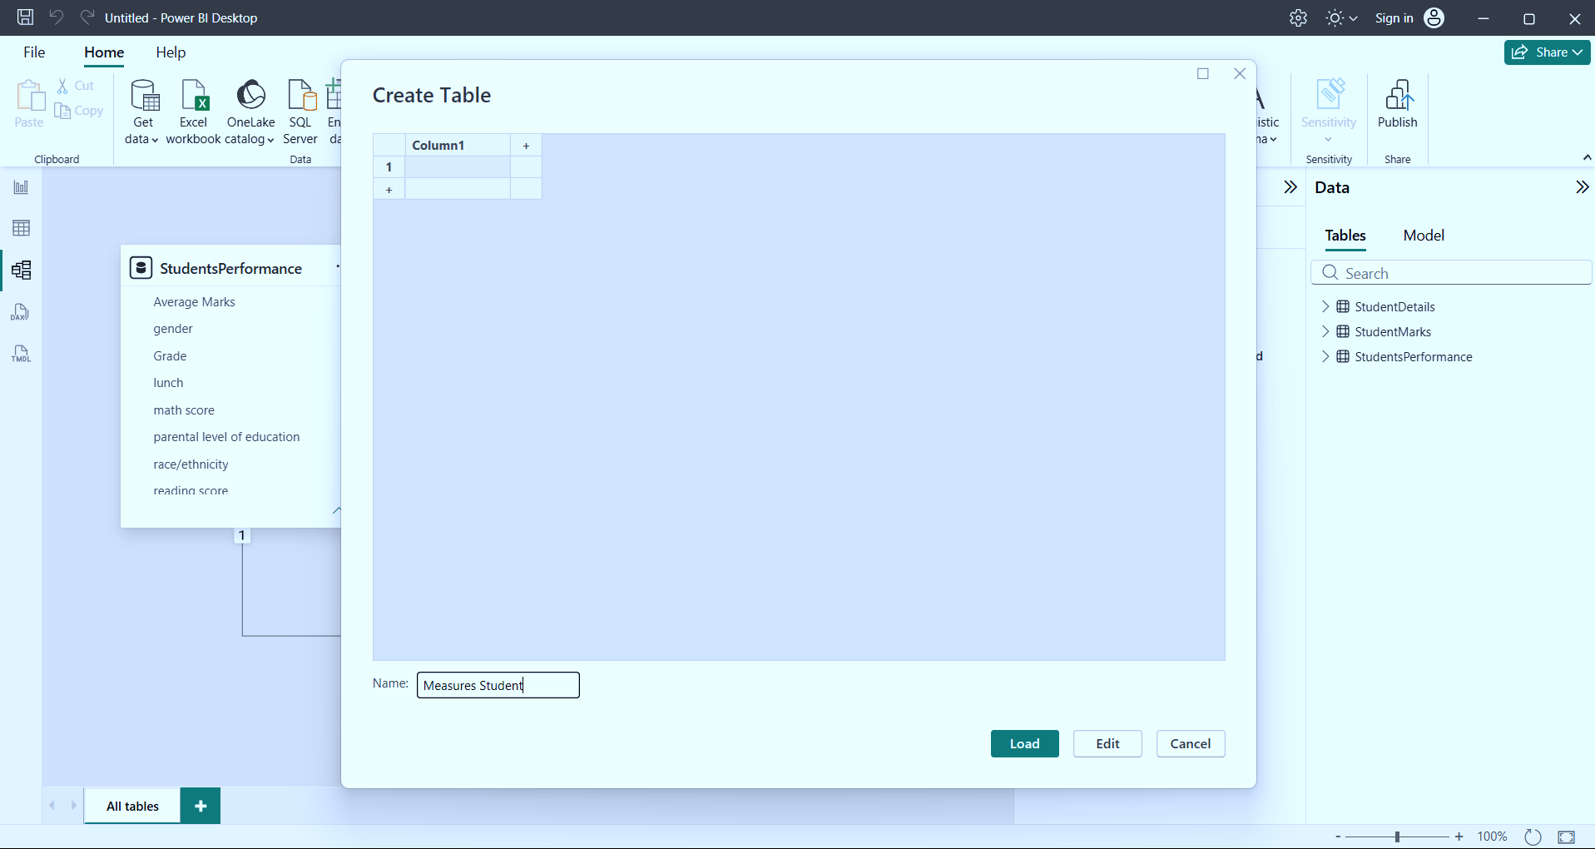
Creating Average Reading Score
The Average Reading Score measure was created using the AVERAGE function.
The formula used was:
Average Reading Score =
AVERAGE(StudentsPerformance[reading score])
This measure calculates the average Reading score obtained by the students.
It can be used to compare Reading performance with the other subjects and can also be displayed as a KPI in the final dashboard.

Creating Average Writing Score
The Average Writing Score measure was created in the same way using the AVERAGE function.
The formula used was:
Average Writing Score =
AVERAGE(StudentsPerformance[writing score])
This measure calculates the average Writing score of all students.
Together, the Average Math Score, Average Reading Score and Average Writing Score measures provide a clear view of the students' performance in each subject.

Creating Overall Average Score
The Overall Average Score measure was created to calculate a single average value representing performance across all three subjects.
The formula used was:
Overall Average Score =
DIVIDE(
[Average Math Score] +
[Average Reading Score] +
[Average Writing Score],
3
)
The three subject-level average scores are added together and then divided by 3.
This provides an overall average score across Math, Reading and Writing.
The measure is useful for giving a single summary value that represents the general academic performance of the students.

Creating Overall Pass %
The Overall Pass % measure was created to find the percentage of students who successfully passed according to the defined passing condition.
The formula used was:
Overall Pass % =
DIVIDE(
CALCULATE(
COUNT(StudentsPerformance[Result]),
StudentsPerformance[Result] = "Pass"
),
DISTINCTCOUNT(StudentsPerformance[Student ID]),
0
)
The measure first counts the number of students whose Result is marked as Pass.
This value is then divided by the total number of unique students using DISTINCTCOUNT.
The result gives the overall percentage of students who passed.
This measure is useful for displaying the pass rate as a KPI or card in the final Power BI.
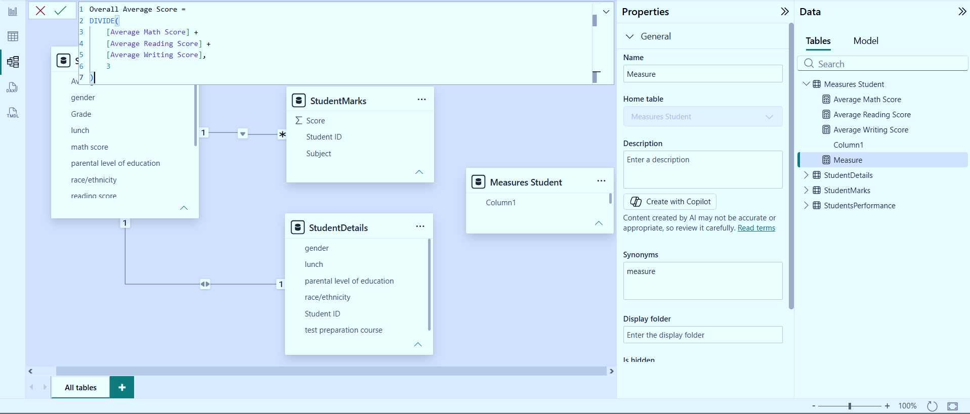
Final Data Model
After completing the required transformations and calculations, the final Power BI model consisted of the following main tables:
- StudentsPerformance
- StudentMarks
- StudentDetails
- Measures Student
The StudentsPerformance table contains the original student information along with the calculated columns such as Total Marks, Average Marks, Grade and Result.
The StudentMarks table contains the subject-wise score information in an unpivoted format. It includes Student ID, Subject and Score, which makes it easier to analyse performance across different subjects.
The StudentDetails table contains the main student-related information such as gender, race/ethnicity, parental education, lunch type and test preparation course.
The Measures Student table contains the DAX measures created for analysing the student performance data.
Overall, the final data model provides a more structured and organised way to analyse the Student Performance dataset. The transformations performed in Power Query helped clean and prepare the data, while the calculated columns and DAX measures provided useful academic performance indicators such as total marks, average marks, grades, pass/fail status, subject averages and overall pass percentage.
This structured model can be used to create an interactive Power BI dashboard that gives a clear understanding of student performance and allows the data to be analysed from different perspectives.
